Singular Joy – Playa del Carmen

Units: 116 condos 1, 2 and 3 bedrooms
From $194,000 USD
Payment: Cash payment

LOCATION: Av 1 y Calle 14, Playa del Carmen, Quintana Roo

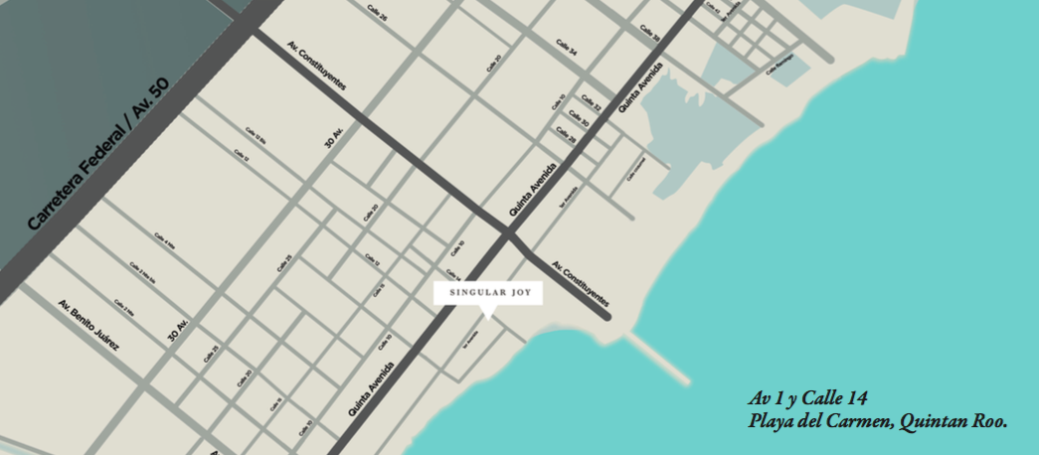

AMENITIES

- 3 infinity pools.
- Sky bar.
- Concierge.
- Room service.
- Spa.
- Gym.
- Housekeeping.
- WiFi.

PHOTOS

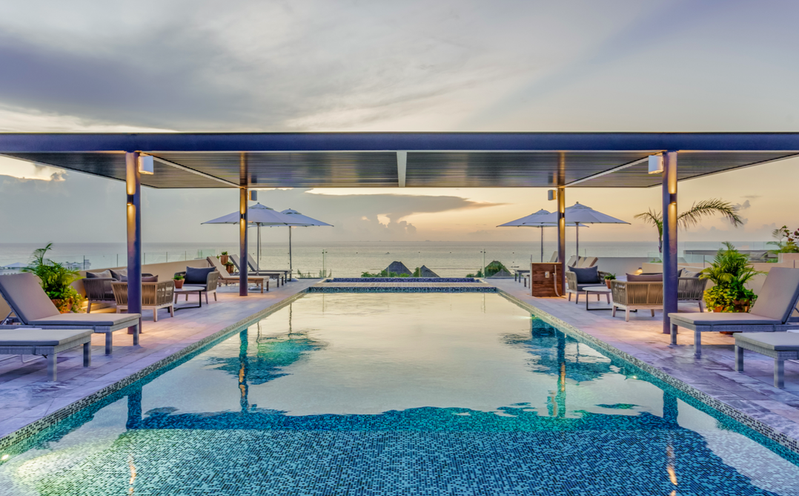

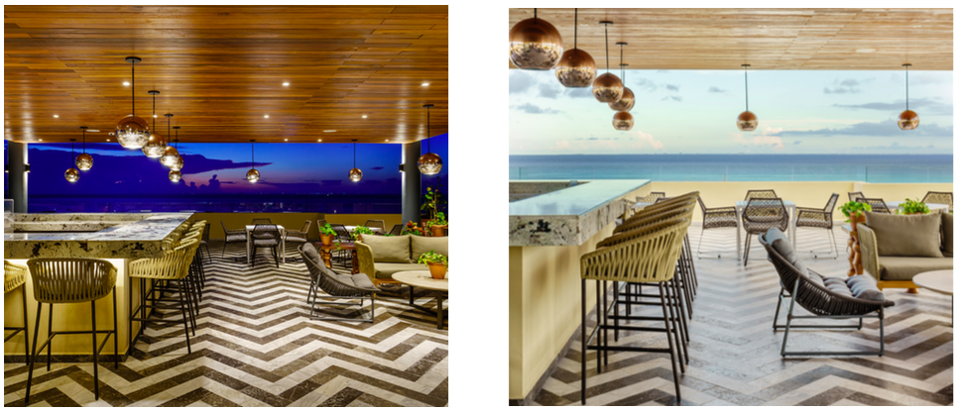

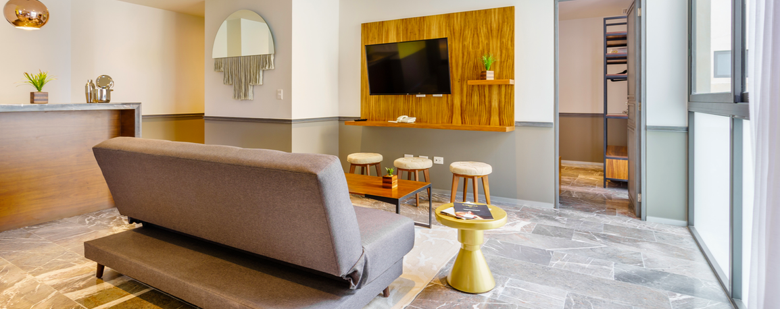

FLOOR PLANS
39.37 m²

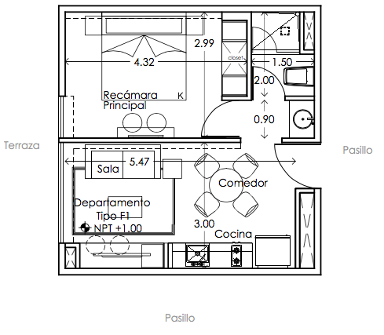

46.98 m²
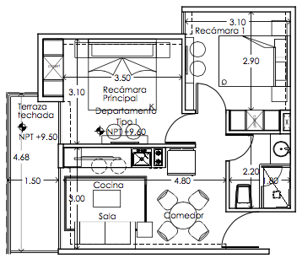

57.13 m²
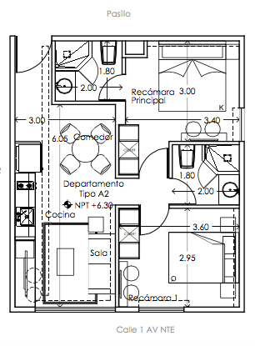

65.58 m²
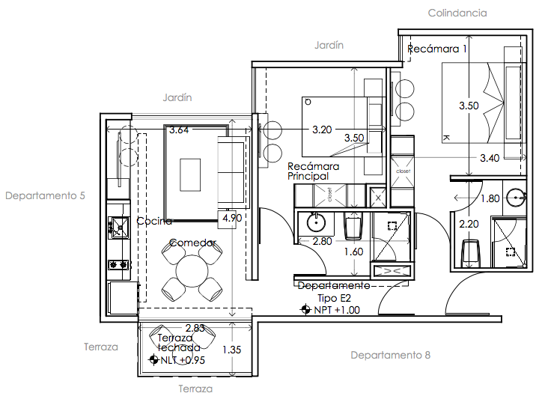

79.37 m²
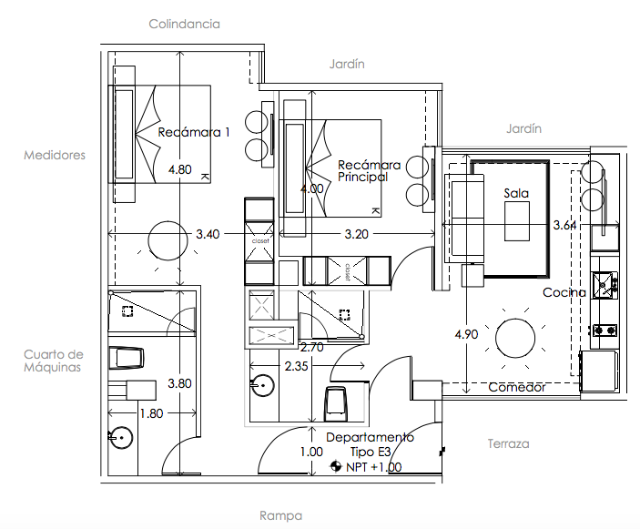
108.85 m²
